Summer Newsletter 4
Friday 24th May

Dear Parents and Carers,

Bags to School collection

The next collection for Bags to School is Friday 7th June. Bags have been given out to the children today to take home. Please fill your bag with as much as you can, spare bags are available from the office if you need them……….. The more bags we fill, the more money we raise.
Collection day is the morning of Friday 7th June.

National Child Measurement Programme-Heights & Weights check for Reception & Year 6
The school nurses will be visiting us during the morning of Thursday 6th June to undertake this
annual check with the Reception and Year 6 children. Letters have been sent home with the children several weeks ago. If you are happy for your child to be measured, you need take no action. If you do not want your child to participate, and have not already done so, please complete and return the form provided to the school office before 5th June. Thank you.

Class 1
Class 1 have had a very busy week this week. Here are some photos off some of the things they have been doing.

Den building at Forest School

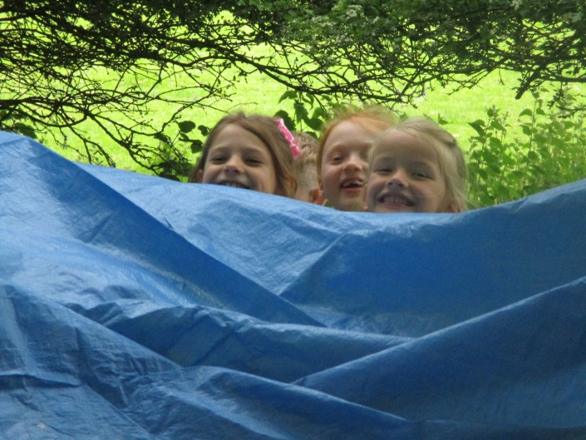
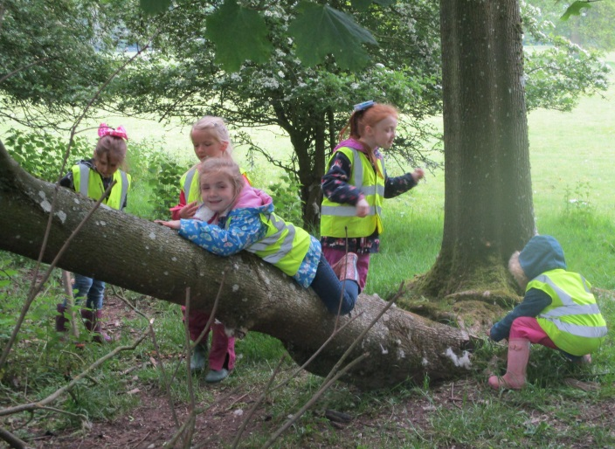
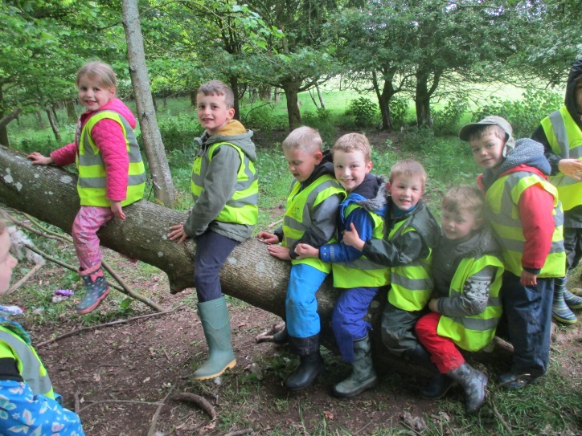
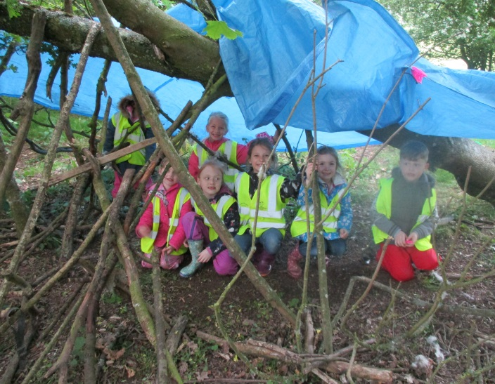

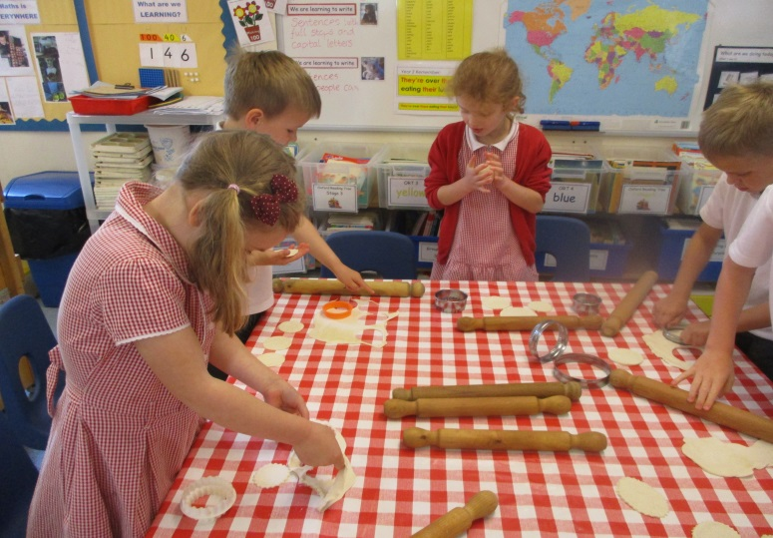
Cooking
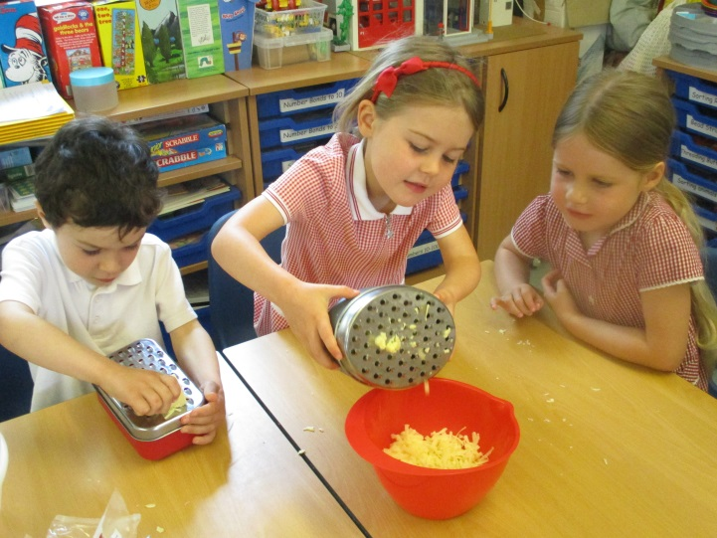

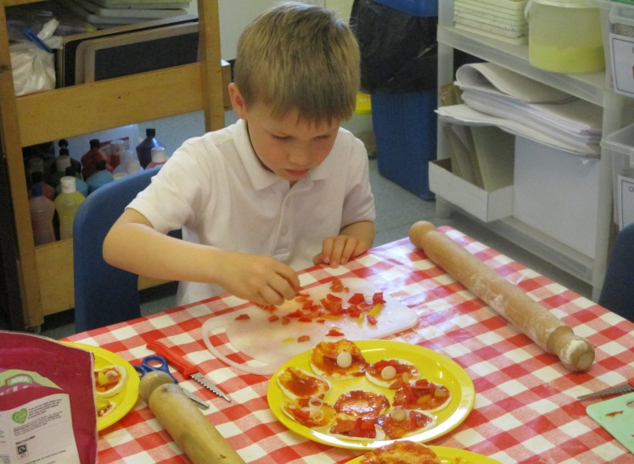
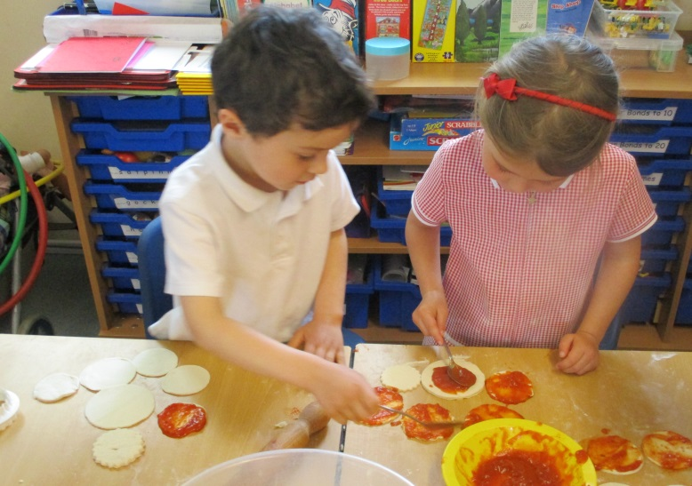

Impromptu visit of some very fluffy babies

Thank you to Mrs Pumfrey for bringing in goslings, a turkey chick (a poult) and a chick. As you can see, the children loved them.
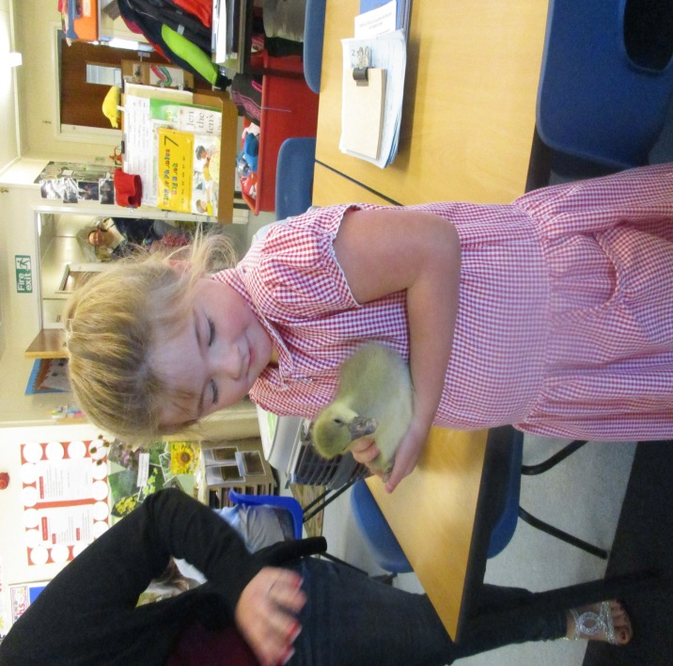
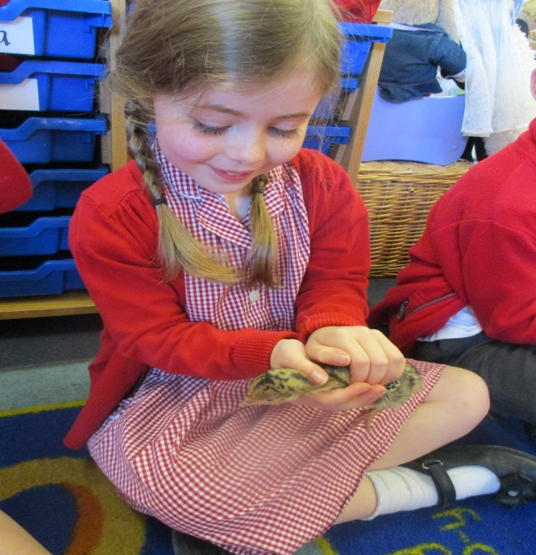

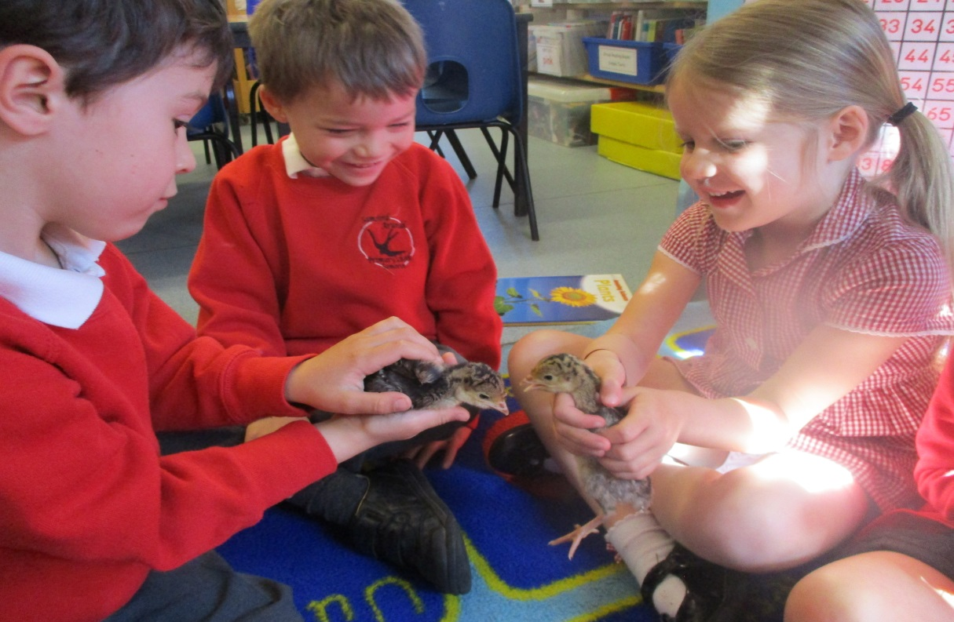

National Child Measurement Programme-Heights & Weights check for Reception & Year 6
The school nurses will be visiting us during the morning of Thursday 6th June to undertake this
annual check with the Reception and Year 6 children. Letters have been sent home with the children several weeks ago. If you are happy for your child to be measured, you need take no action. If you do not want your child to participate, and have not already done so, please complete and return the form provided to the school office before 5th June. Thank you.

Class 2 Residential Trip Monday 10th June to Friday 14th June

This years’ Residential Trip has been booked for the above dates at Charterhouse Residential Education Centre in the Mendips and will be a fantastic opportunity for the children to meet and make new friends while also taking part in activities which we cannot provide on the school premises. It also gives the children the chance to live and work together for the week. A letter has been sent out this week and Mrs Horne has added a payment item on Parentpay for the cost of this trip. It has been set up in a way that payments can be made in instalments to help spread the cost. Please can you ensure that all permission slips are handed into the office asap. Thank you all for returning the Medical Forms as requested.
Class 2
Class 2 have also been very busy this week. The year 6 children have been out enjoying the lovely weather on their bikes, taking part in Bikeability and some of class 2 took part in an athletics tournament on Thursday after school. Well done to all the children that took part.
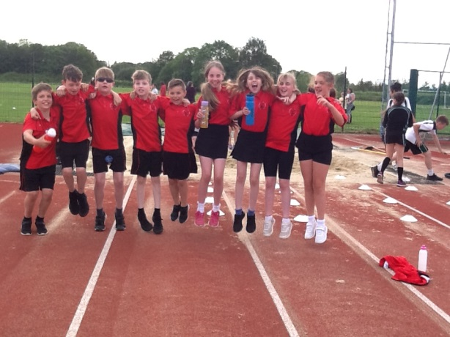
Athletics

Bikeability
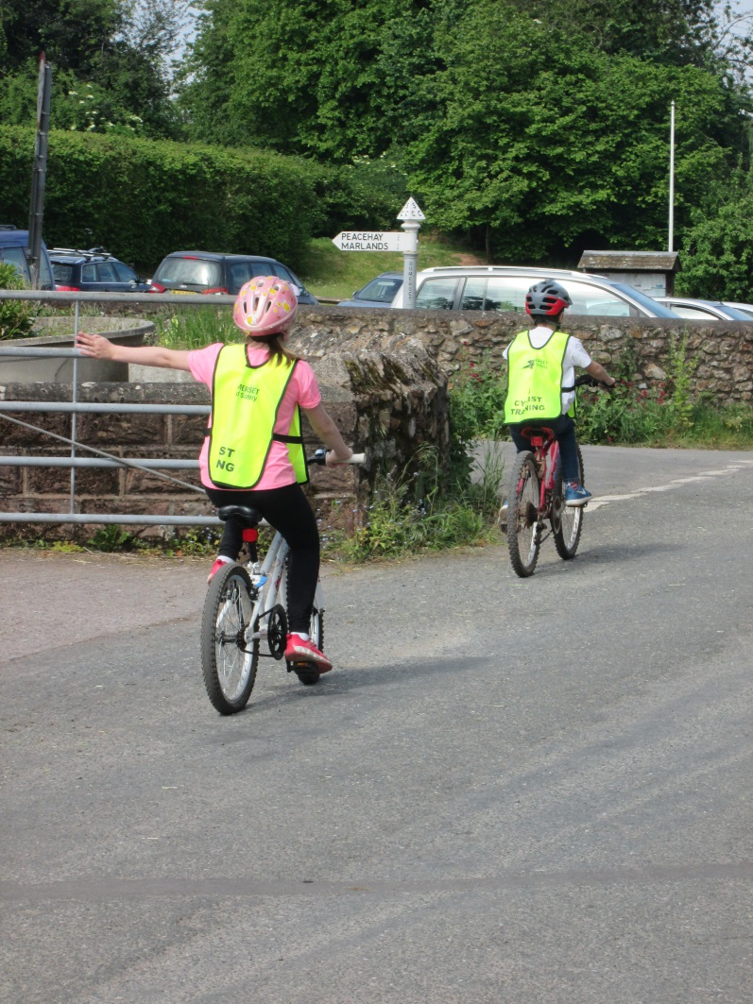
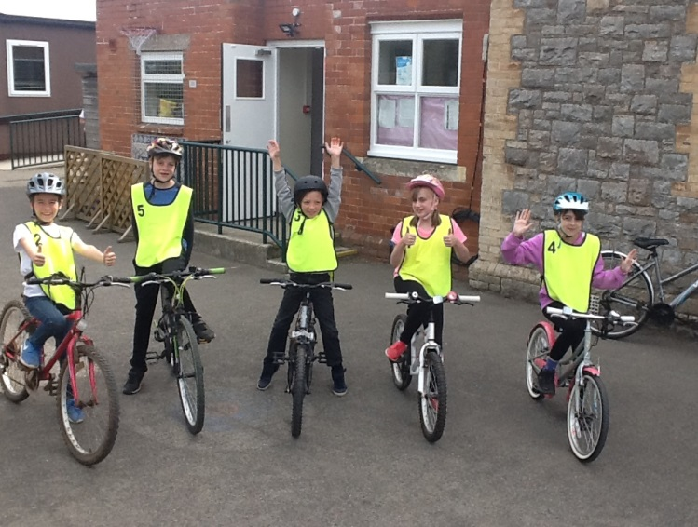

Rounders Tournament at Court Fields on Monday the 20th of May.
The children who went were Harry, Rowan, Jacob, Henry, Harley ,Imogen, Finnegan, Joby, Caitlin and Abbie.
We played five matches. Although we didn’t win any, a couple were really close. We have improved, but we still need to work on our batting. Thank you to Mrs Johnson for going with us and to the parents who took us.
By Harry and Rowan.

Half Term commences after school on Friday 24th May and the children return to school on TUESDAY 4th JUNE.

As ever, thank you for your ongoing support with all of our endeavours to make Sampford Arundel a truly community focused school and on behalf of all the staff may I wish you all a very happy half term holiday.

With very best wishes
Jacqui Collier
FORTHCOMING EVENTS/DATES

- HALF TERM : W/C 27th May
- INSET DAY : Monday 3rd June
- Year 5/6 Cycling : Tuesday 4th June Richard Huish College 12.30pm to 3pm
- Weights & Measures Team : Thursday 6th June Reception & year 6
- Quadkids yr 3 & 4 : Thursday 6th June 9.45am to 12.30pm
- Quadkids yr 5 & 6 : Thursday 6th June 2.30pm to 5.15pm
- Bags of Help Collection : Friday June 7th
- Sex Ed Meeting : Friday 7th June Class 2 parents 3.30pm
- Class 2 Residential : Monday 10th June to Friday 14th June Charterhouse
- Donkey Sanctuary Visit : Wednesday 19th June
- Come & have a go Athletics : Thursday 20th June Yr 1 & 2 Bridgwater & Taunton College (SCAT) 3.50pm to 5.30pm
- Guitar Performance : Thursday 20th June 1.30pm in class2
- Cross Country : Monday 24th June Kings College 4.15pm
- Courtfields Visit : Tuesday 2nd July - year 6
- Courtfields Visit : Wednesday 3rd July – year 6
- KS2 Performance : Tuesday 9th July 6.00pm at School
- KS2 Performance : Wednesday 10th July 2.00pm & 6.00pm at School
- Sampford Arundel Fete : Saturday 13th July 2.00pm to 4.30pm
- Sports Day : Thursday 18th July School Field
- Last day of term : Friday 19th July
- INSET DAY : Monday 22nd July
- INSET DAY : Tuesday 23rd July
- INSET DAY : Monday 2nd September
- Children return to school for New Academic Year : Tuesday 3rd September
- Half Term commences at 3.15pm : Thursday 24th October
- INSET DAY : Friday 25th October
- Children return to school : Monday 4th November
- End of Term commences at 3.15pm : Friday 20th December
- INSET DAY: Monday 6th January 2020
- INSET DAY: Friday 26th June 2020
- INSET DAY : Monday 20th July 2020

